Kickstart Fundraising Summery

Being in successful in a fundraising depends on many parameters. Here we are looking at some of them:

* **The month of starting the fundraising:**

The fig.1 shows we have the highest number of successful fundraising on May and the lowest on December. Although it shows that it is dropping down after May until September, the fig.2 shows based on the total of fundraising on each month the percentage of successful are about 50% .

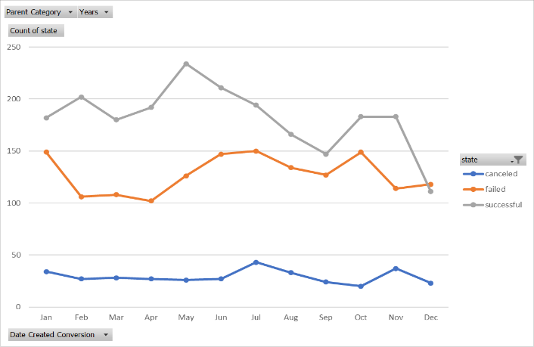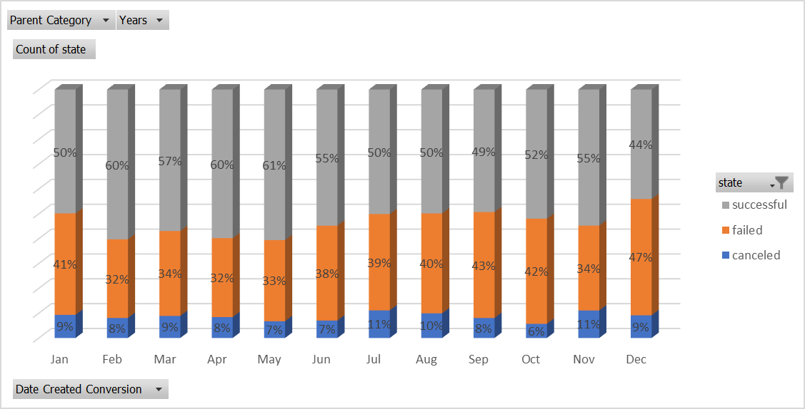

Fig. 1 Fig. 2

* **The Category of fundraising:**

The fig.3 shows the most popular and successful project is “Plays” and the “Rock music” and “Documantry” are the next successful fundraising without any failed or cancelation. On the other hand, some categories such as “animation”, “Food Trucks” , “Video games” were failed however , the fundraising started.

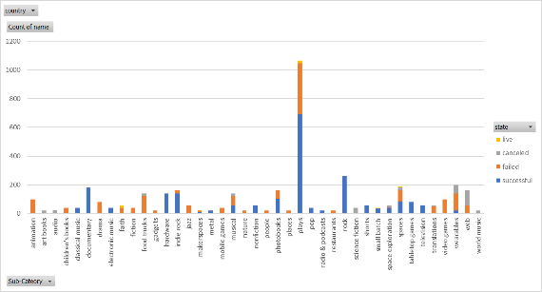

Fig. 3

“Journalism” is not the popular one as all the fundraising was cancelled base on fig.4. Although “Theatre” is the most popular one , “Music” has the most percentage of the successful projects.

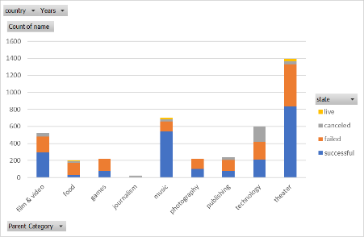

Fig. 4

* **The interest of Backers:**

The Top 10 interesting categories by backers, Fig.5 , shows the “Technology” is the most popular one and “Hardware” is getting their attention more in this categories . In addition “Documentary “, Plays” and “Rock” are still in Top 10 interesting categories as they are the in the Top10 number of fundraising too.

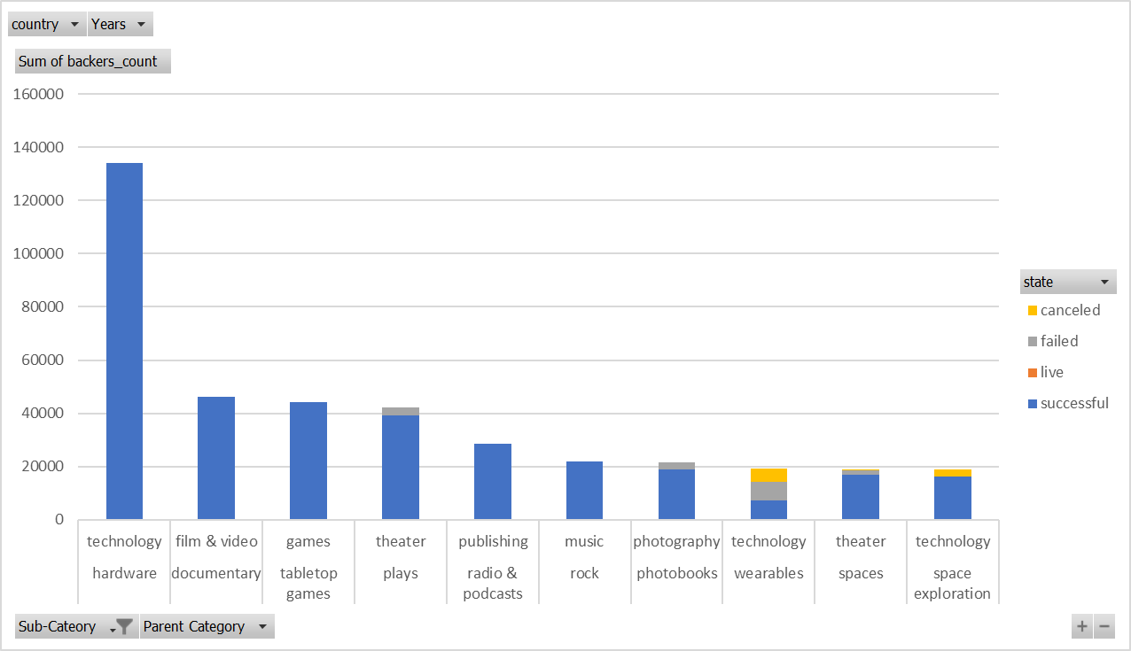

Fig.